INTERNSHIP PROPOSAL (Master 1, Master 2)

Title : Root growth in granular soils: impact of mechanical stress on morphogenesis

Supervisor : Evelyne Kolb
evelyne.kolb@upmc.fr
Location : PMMH, ESPCI, Paris (France)

The mechanical and topological properties of a soil like the global porosity and the distribution of void sizes greatly affect the development of a plant root, which in turn affects the shoot development. In particular, plant roots growing in heterogeneous medium like sandy soils or cracked substrates have to adapt their morphology and exert radial forces depending on the pore size in which they penetrate.
Our team is interested in the coupling and retroaction between the root growth and the reorganization of the soil, i.e. what are the forces a root is able to develop on its environment and how the mechanical stress affects the root growth (morphogenesis)?
This subject emerges from a multidisciplinary collaboration between Evelyne Kolb (PMMH, ESPCI), a physicist initially working on granular materials, Christian Hartmann (IRD), a soil scientist expert in real soil compaction and rehabilitation, and Patricia Genet (BIOEMCO,ENS), a biologist specialised in mycorrhizae.

To study such soil/root interactions we examine root penetration of medium in a model system made of a single pore between solid constituents. Till now, we worked with a model experiment in which a pivot root (chick-pea seeds, Cicer arietinum L.) of millimeter diameter had to grow in the constriction between two grains in a two-dimensional cell (Fig.1). The root diameter increase was limited by the steric constriction imposed by the gap between the two disks forming the solid phase. The essential point of this experimental set up was that the disks were made of a photoelastic material allowing us to monitor the radial compression force developed by root growth. Thus we measured in situ, simultaneously and up to five days i) the morphological changes induced by the steric constriction and ii) the root’s radial forces exerted on the surrounding material (i.e. photoelastic disks) [Kolb, Hartmann, Genet, Plant and Soil 2012].
For this lab training we propose now to study the impact on root growth of a tridimensional (3D) pore of various rigidities. The root has to grow inside a polymeric tube (Fig.2), which radii, length and Young modulus can be varied. This tube exerts a radial and circumferential stress on the growing root. It mimics a 3D pore between reorganisable grains. By image analysis we will quantify how this localized stress will affect the root growth. In particular we will measure the axial growth velocity and the changes of root diameters before and after the tube location and compare these morphological parameters to controls for roots growing without any applied mechanical stress and to the extreme cases where the tube is completely rigid (glass tube). We will also measure the swelling of the flexible tube and use PIV technique (particle image velocimetry) on it to measure the local strains and possibly infer the radial stress exerted by the root. We also want to relate this macroscopic analysis to microscopic observations of cell morphology by using cell staining and post mortem observations to compute deformations of cell walls and change in the number of cell files.

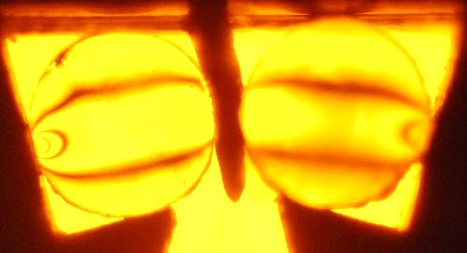 | 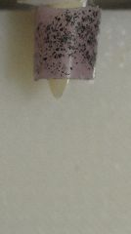 | 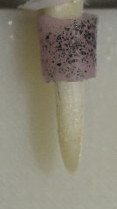
Fig. 1: Root growth (ø ≈1 mm) of a chick-pea seed. The radial root growth exerts a diametrical compression on the two neighboring disks illuminated from behind by a monochromatic light and placed between circular polarizers. The location of optical fringes is linked to the applied force. | Fig. 2 : Root growth of a chickpea seed inside a polymeric tube (purple sleeve). The tube has been marked with black dots of painting for further PIV analyses.

